Test Case: runTestMultipleTimes
Step 1 - Enter username and password and click to button Enter : Credentials Entered
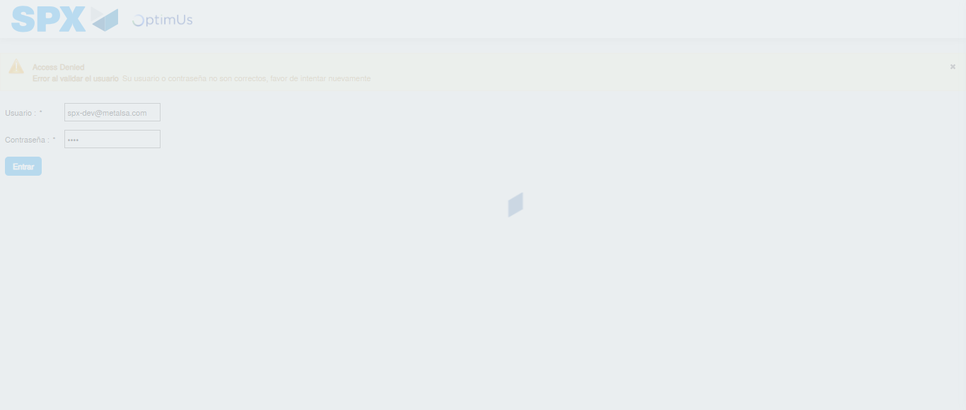Image file-name: QC_Testing-runTestMultipleTimes-dic. 04 2025, 04 05 11 p. m.

Step 2 - Select to UEN and Access to Captura de Cotizaciones: UEN Correctly selected and Correct access
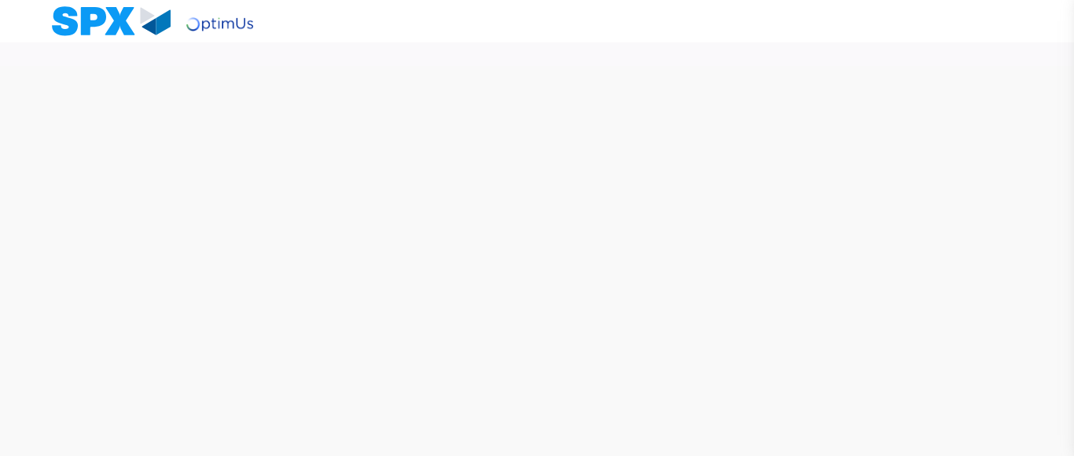Image file-name: QC_Testing-runTestMultipleTimes-dic. 04 2025, 04 05 15 p. m.

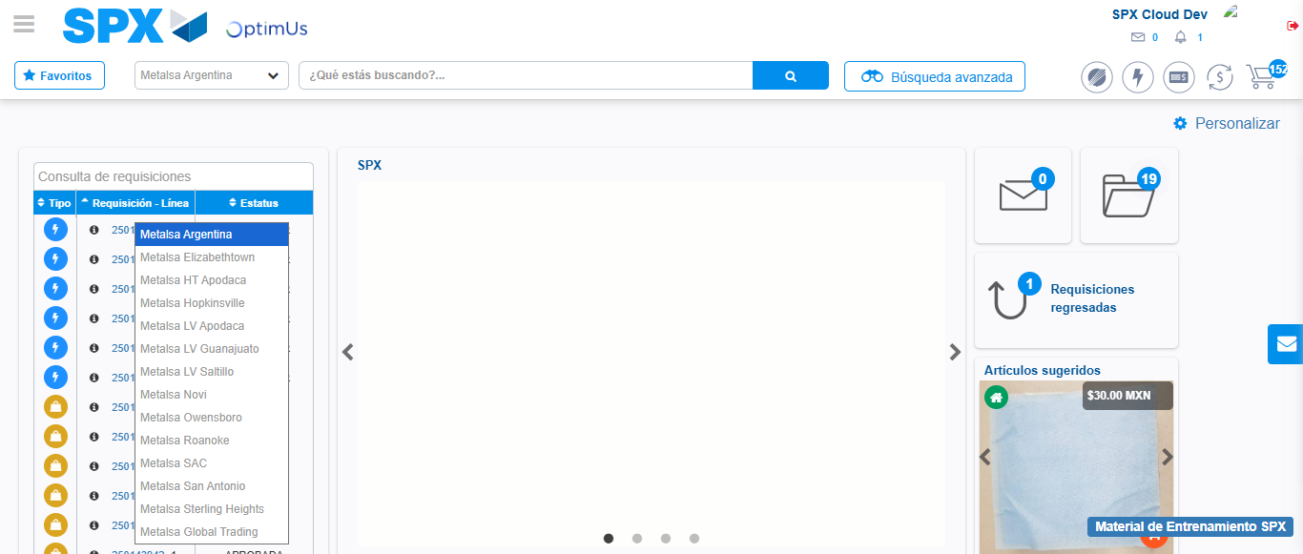Image file-name: QC_Testing-runTestMultipleTimes-dic. 04 2025, 04 05 16 p. m.

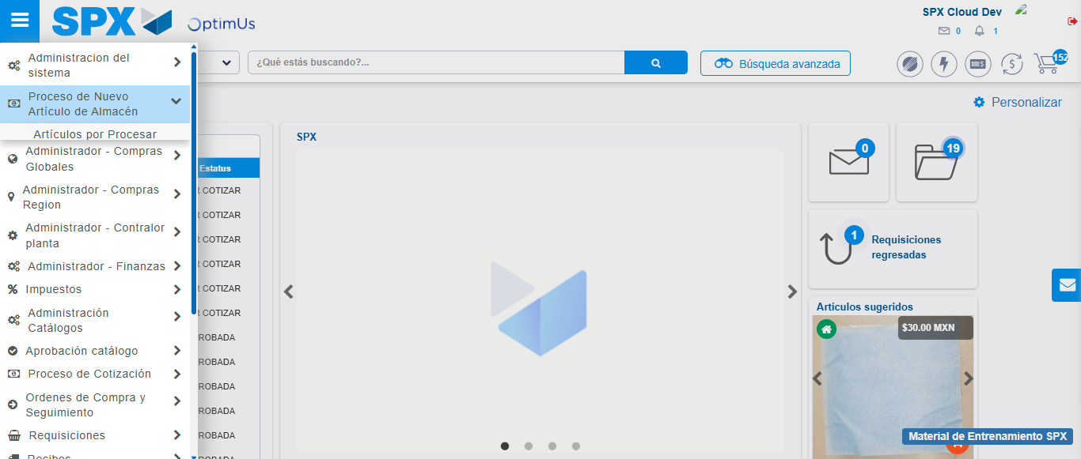Image file-name: QC_Testing-runTestMultipleTimes-dic. 04 2025, 04 05 17 p. m.

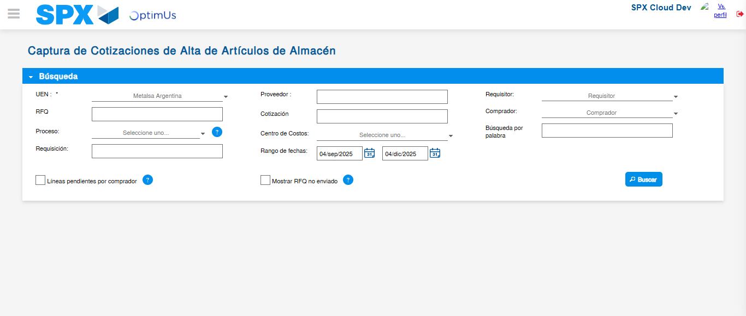Image file-name: QC_Testing-runTestMultipleTimes-dic. 04 2025, 04 05 19 p. m.

Step 3 - Validate search fields: Validated fields
Image file-name: QC_Testing-runTestMultipleTimes-dic. 04 2025, 04 05 19 p. m.

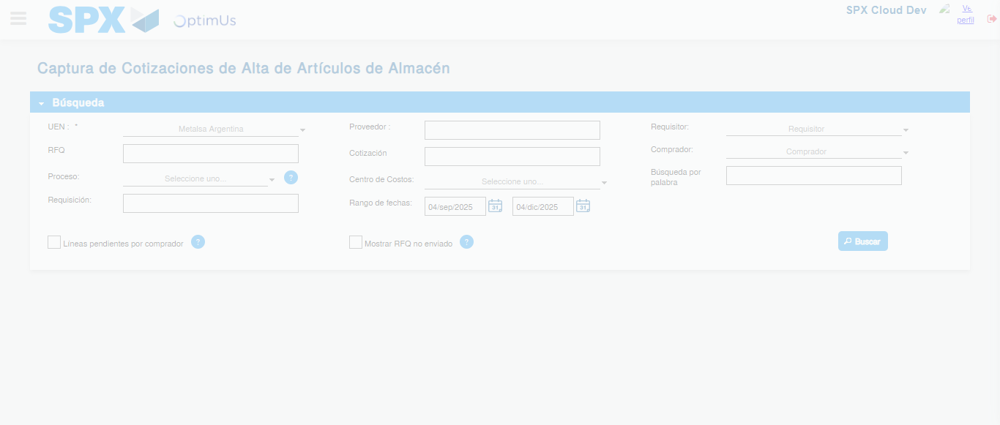Image file-name: QC_Testing-runTestMultipleTimes-dic. 04 2025, 04 05 23 p. m.

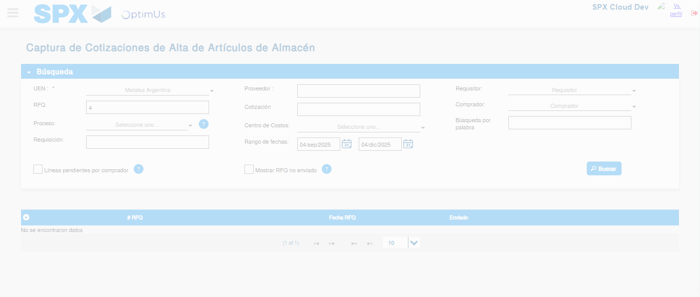Image file-name: QC_Testing-runTestMultipleTimes-dic. 04 2025, 04 05 26 p. m.

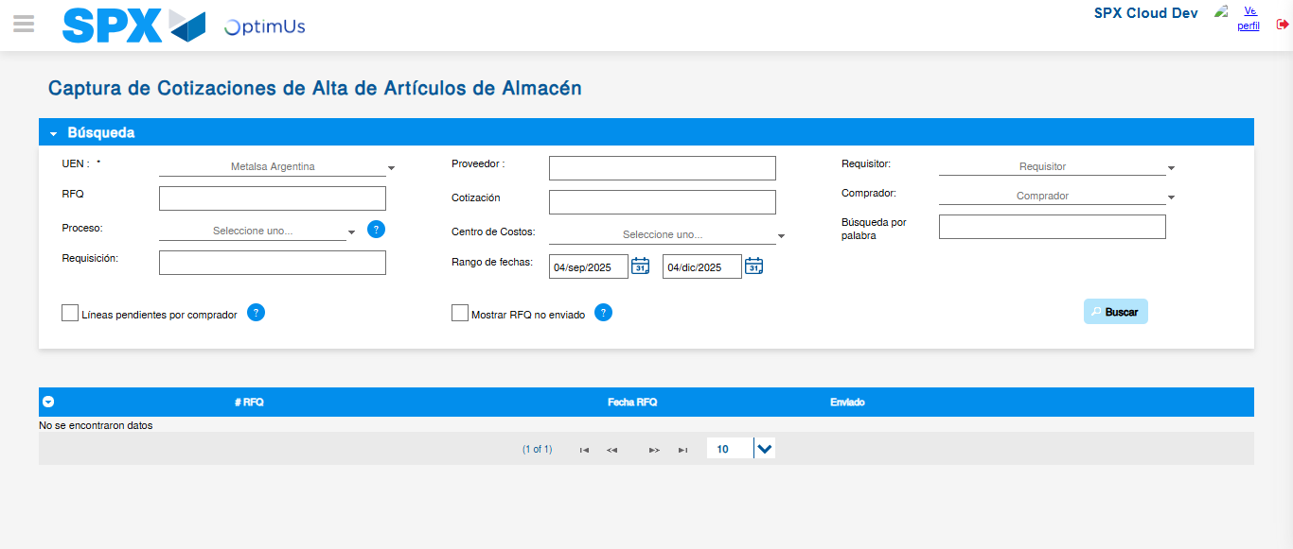Image file-name: QC_Testing-runTestMultipleTimes-dic. 04 2025, 04 05 30 p. m.

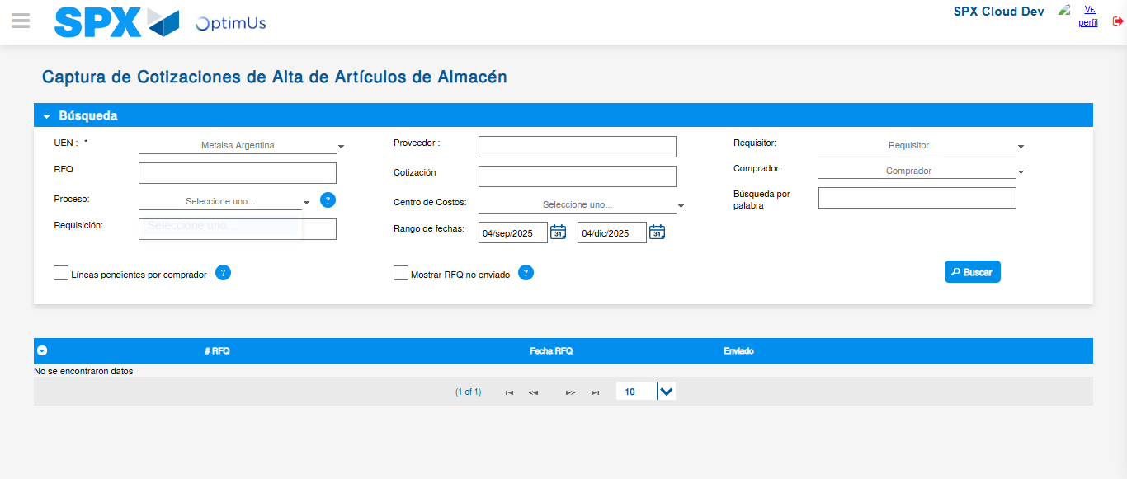Image file-name: QC_Testing-runTestMultipleTimes-dic. 04 2025, 04 05 33 p. m.

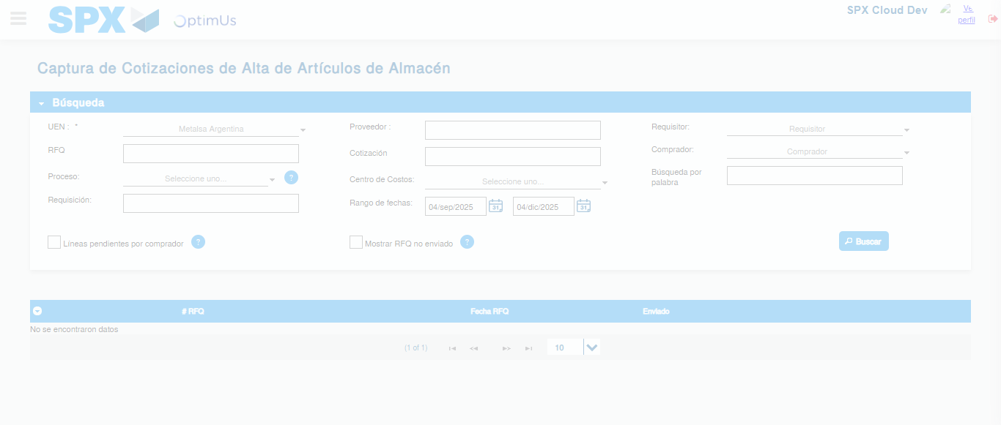Image file-name: QC_Testing-runTestMultipleTimes-dic. 04 2025, 04 05 59 p. m.

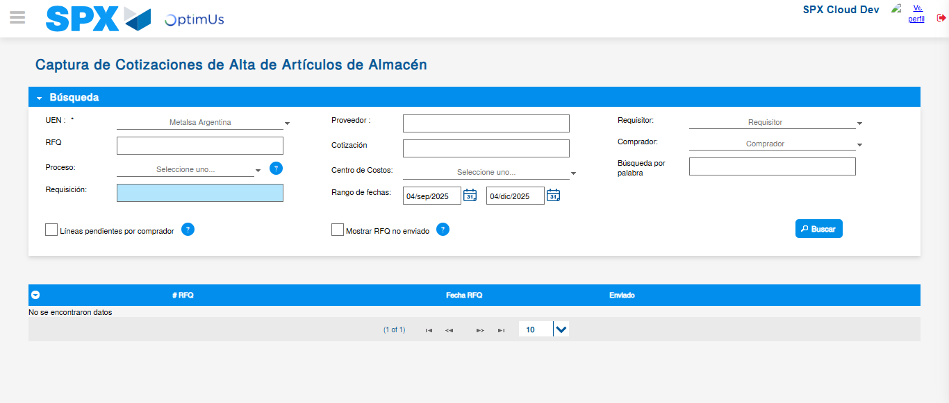Image file-name: QC_Testing-runTestMultipleTimes-dic. 04 2025, 04 06 02 p. m.

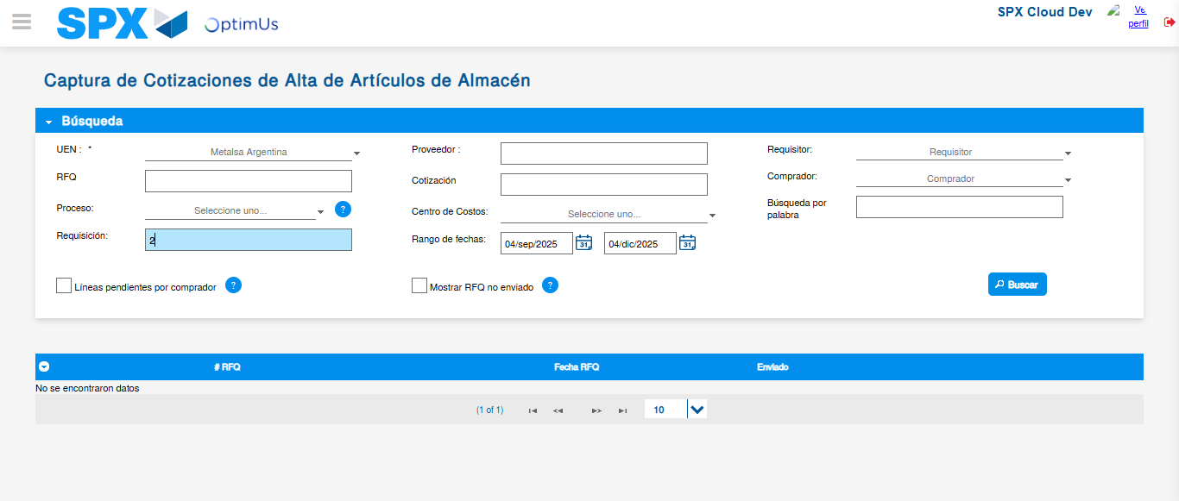Image file-name: QC_Testing-runTestMultipleTimes-dic. 04 2025, 04 06 05 p. m.

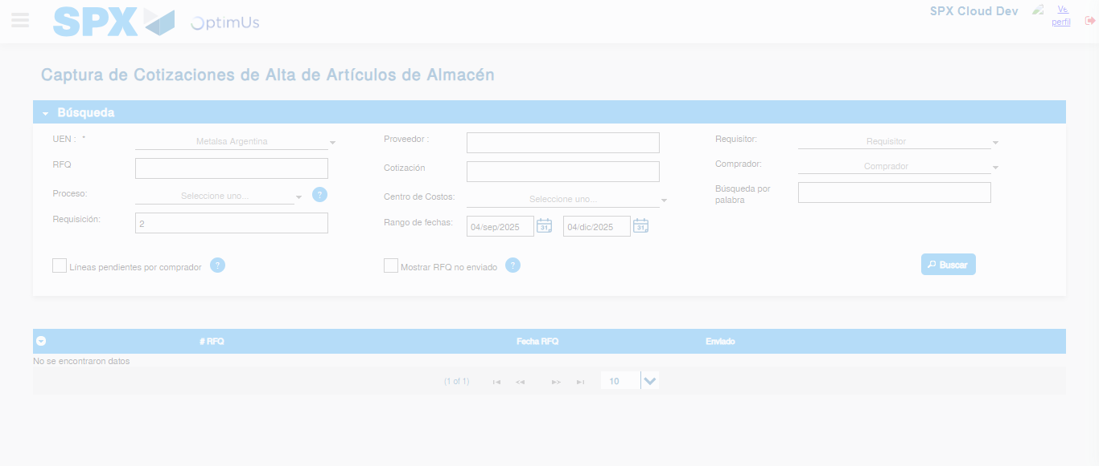Image file-name: QC_Testing-runTestMultipleTimes-dic. 04 2025, 04 06 06 p. m.

Image file-name: QC_Testing-runTestMultipleTimes-dic. 04 2025, 04 06 09 p. m.

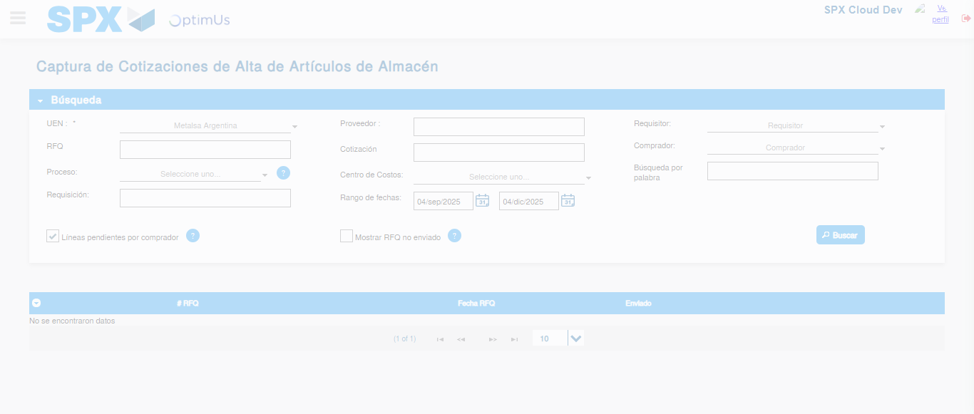Image file-name: QC_Testing-runTestMultipleTimes-dic. 04 2025, 04 06 12 p. m.

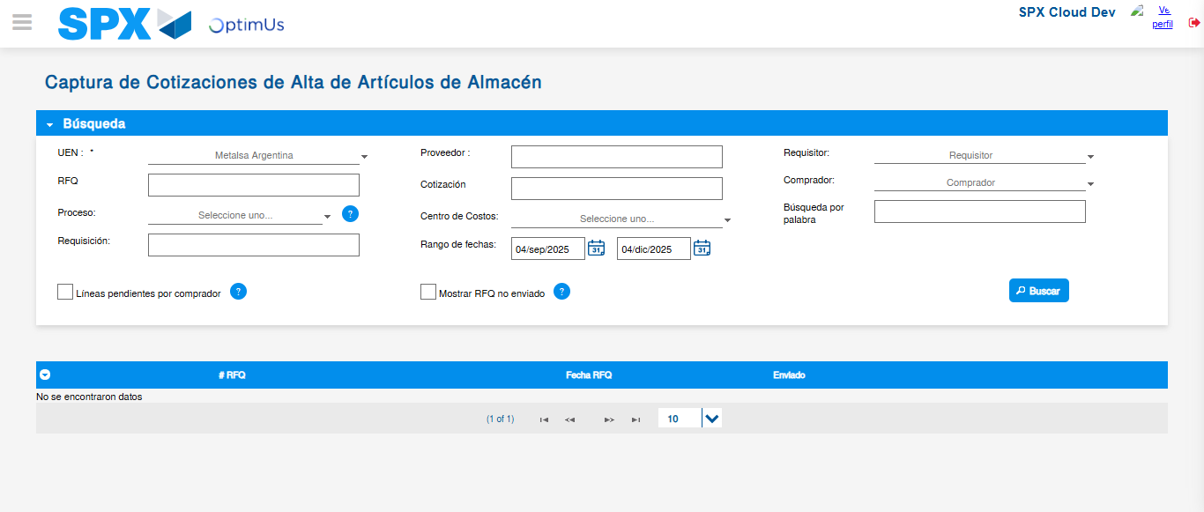Image file-name: QC_Testing-runTestMultipleTimes-dic. 04 2025, 04 06 15 p. m.

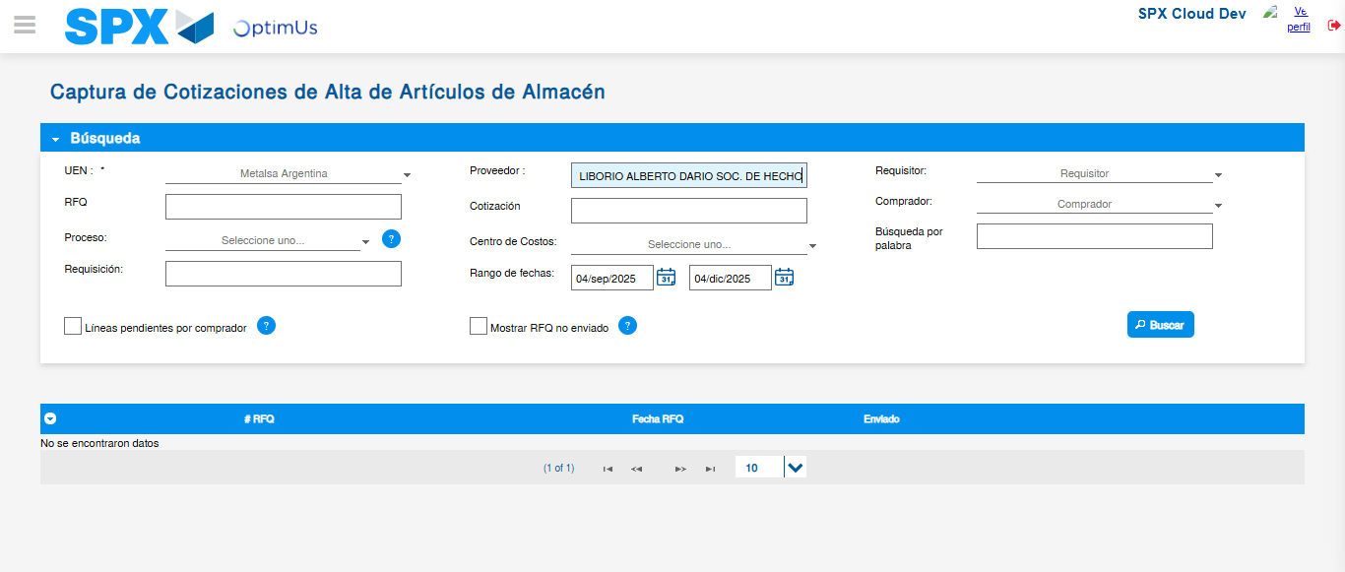Image file-name: QC_Testing-runTestMultipleTimes-dic. 04 2025, 04 06 16 p. m.

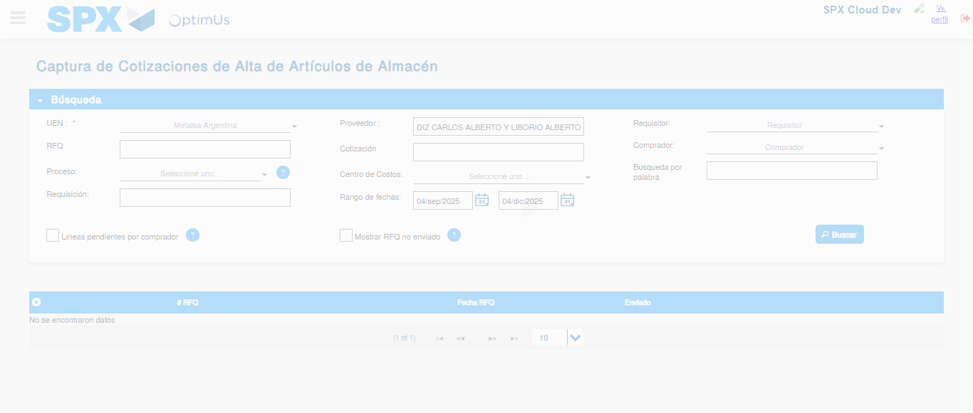Image file-name: QC_Testing-runTestMultipleTimes-dic. 04 2025, 04 06 19 p. m.

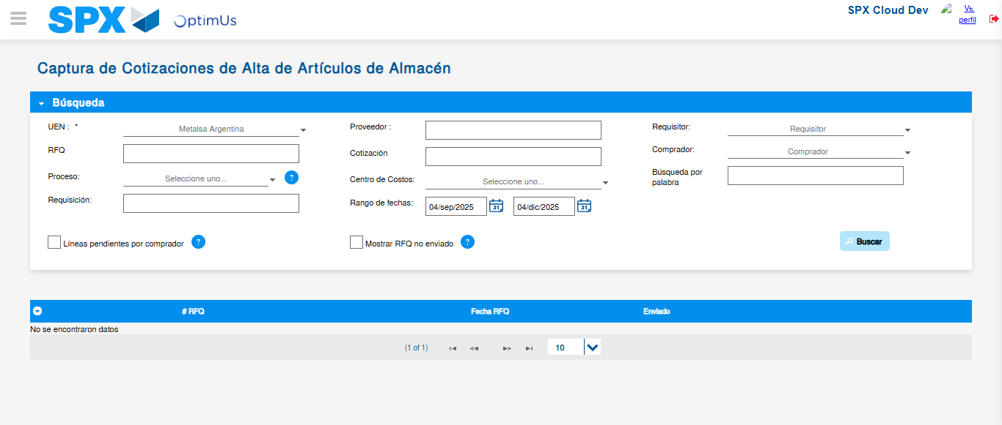Image file-name: QC_Testing-runTestMultipleTimes-dic. 04 2025, 04 06 22 p. m.

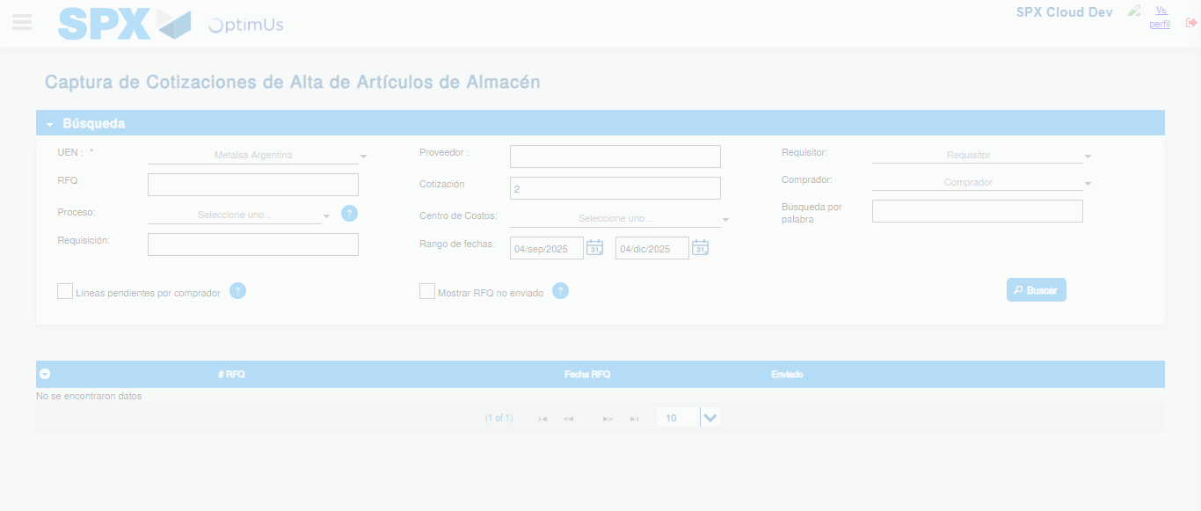Image file-name: QC_Testing-runTestMultipleTimes-dic. 04 2025, 04 06 25 p. m.

Image file-name: QC_Testing-runTestMultipleTimes-dic. 04 2025, 04 06 28 p. m.

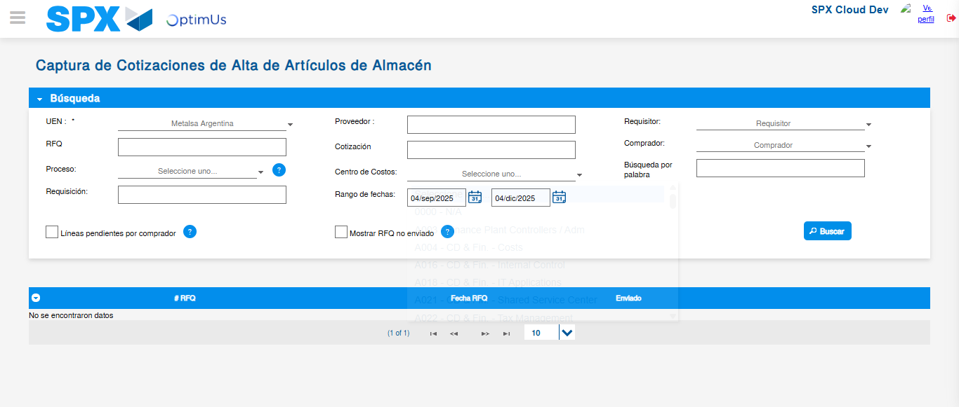Image file-name: QC_Testing-runTestMultipleTimes-dic. 04 2025, 04 06 32 p. m.

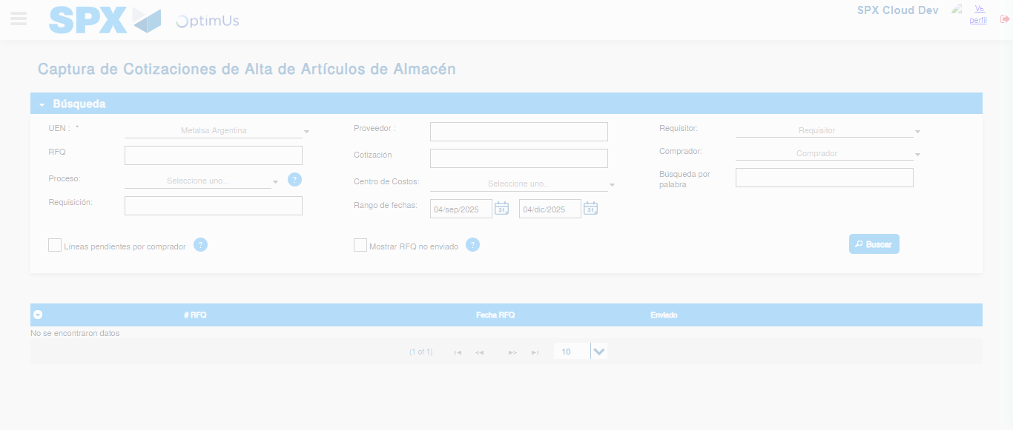Image file-name: QC_Testing-runTestMultipleTimes-dic. 04 2025, 04 07 00 p. m.

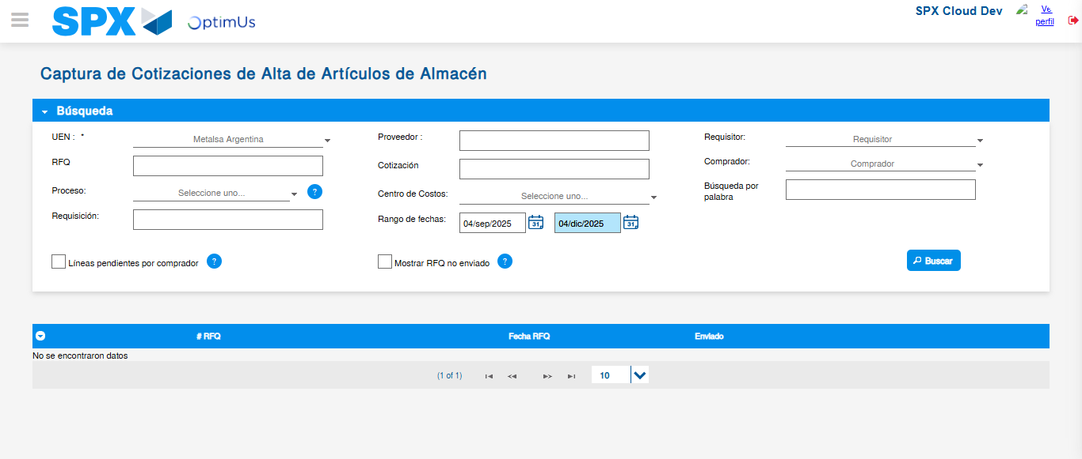Image file-name: QC_Testing-runTestMultipleTimes-dic. 04 2025, 04 07 04 p. m.

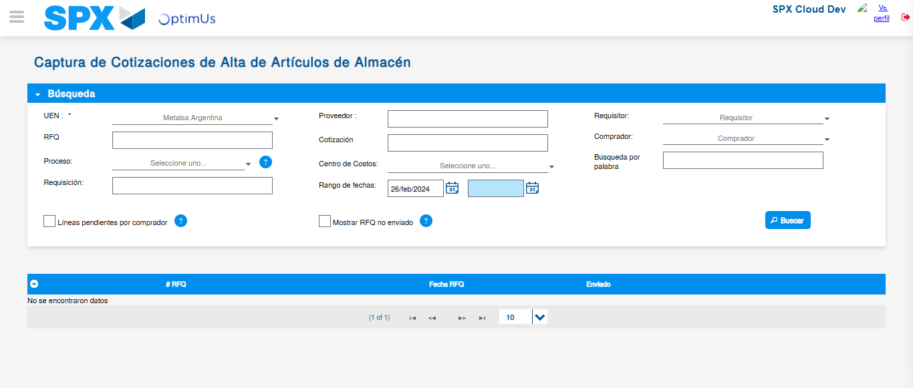Image file-name: QC_Testing-runTestMultipleTimes-dic. 04 2025, 04 07 07 p. m.

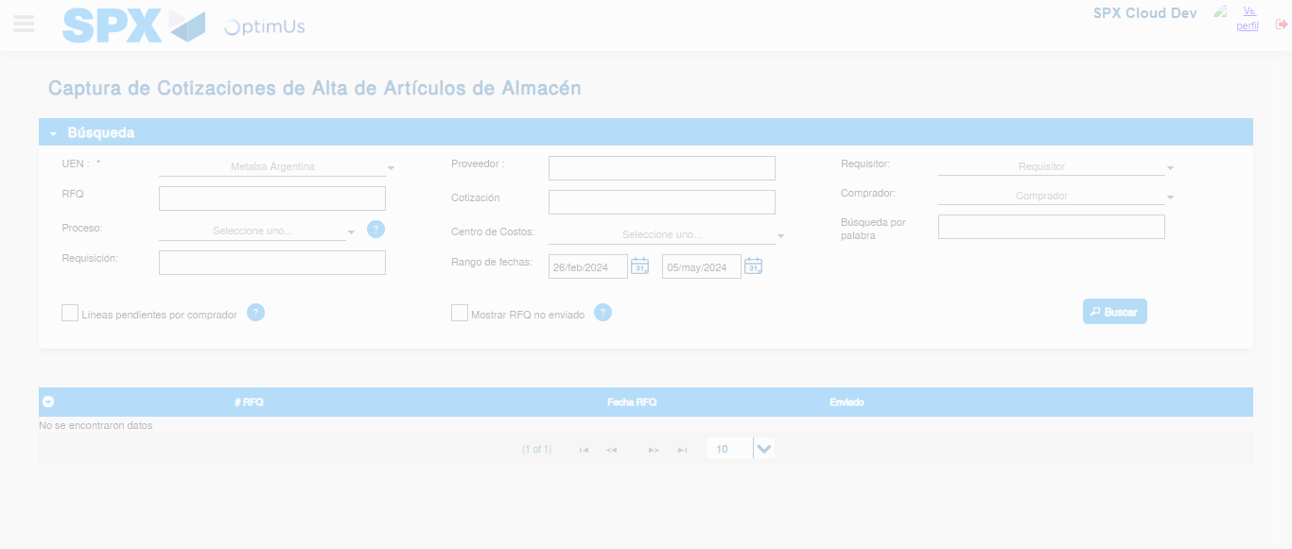Image file-name: QC_Testing-runTestMultipleTimes-dic. 04 2025, 04 07 08 p. m.

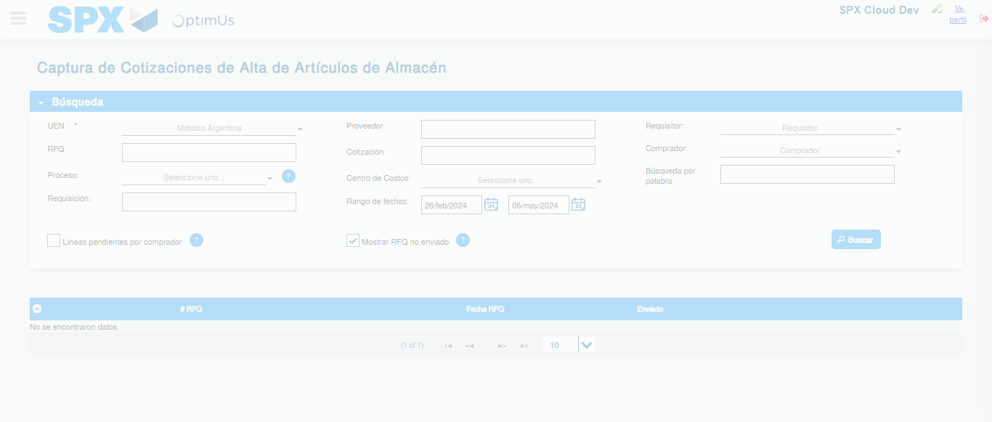Image file-name: QC_Testing-runTestMultipleTimes-dic. 04 2025, 04 07 11 p. m.

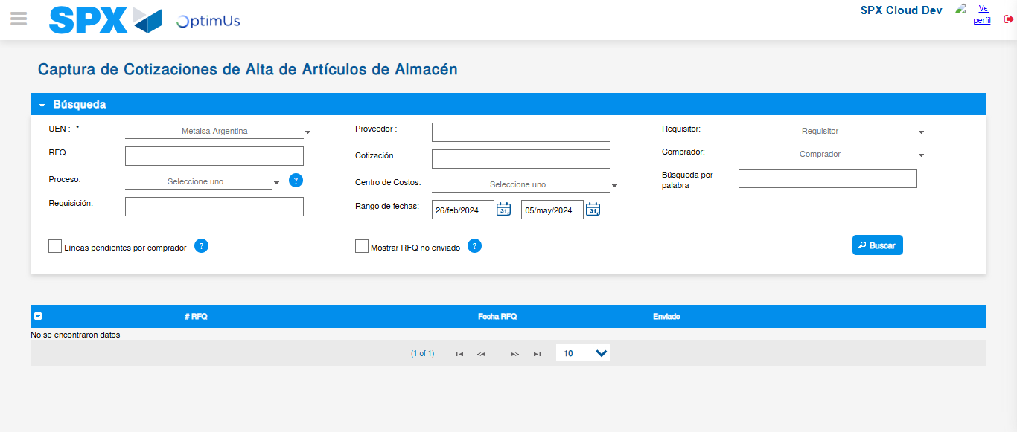Image file-name: QC_Testing-runTestMultipleTimes-dic. 04 2025, 04 07 14 p. m.

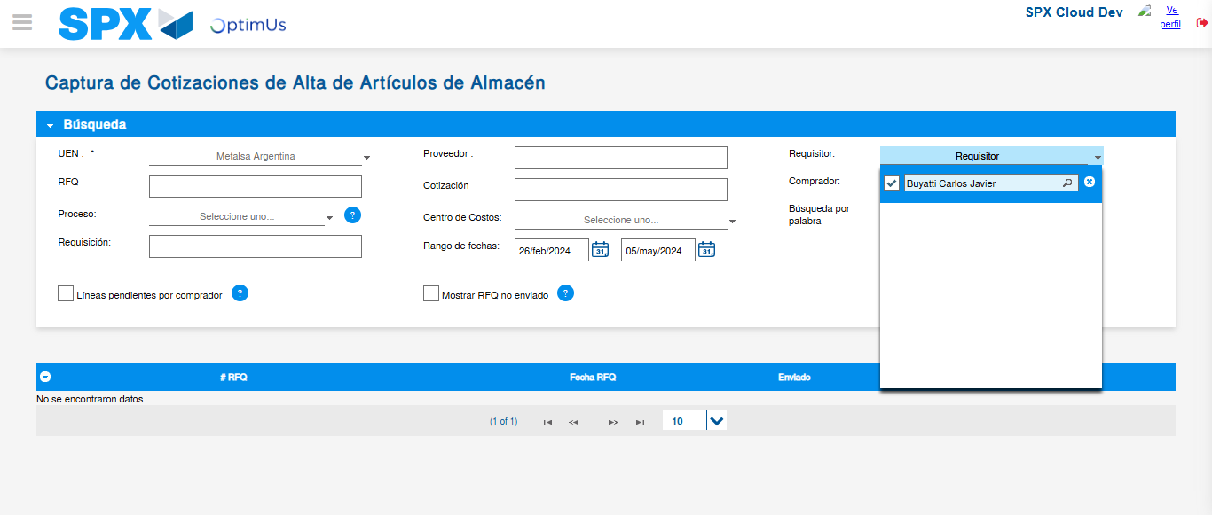Image file-name: QC_Testing-runTestMultipleTimes-dic. 04 2025, 04 07 15 p. m.

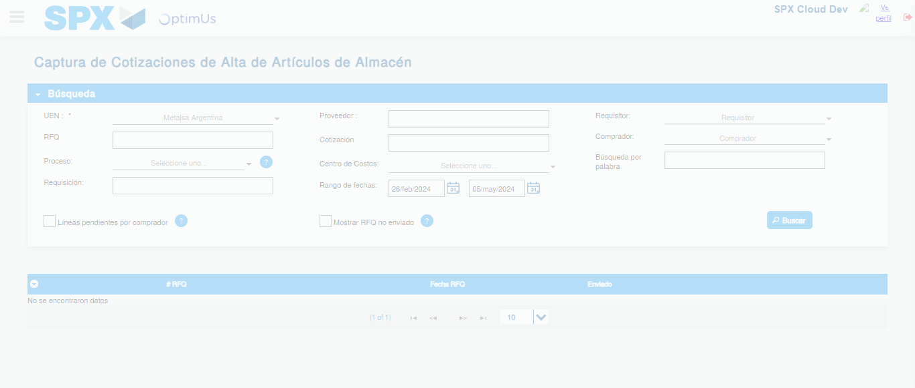Image file-name: QC_Testing-runTestMultipleTimes-dic. 04 2025, 04 07 41 p. m.

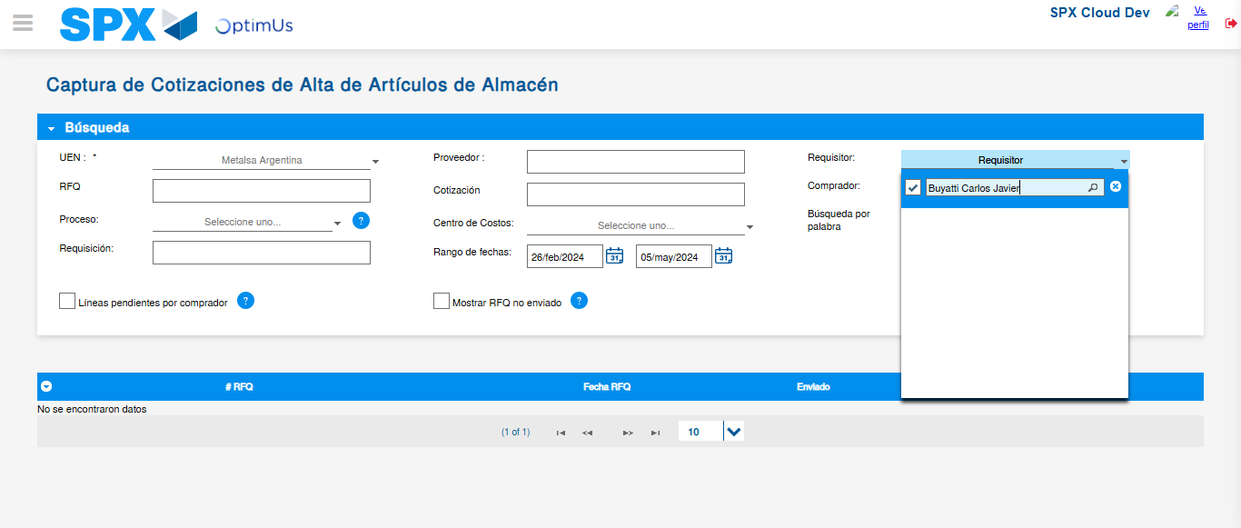Image file-name: QC_Testing-runTestMultipleTimes-dic. 04 2025, 04 07 44 p. m.

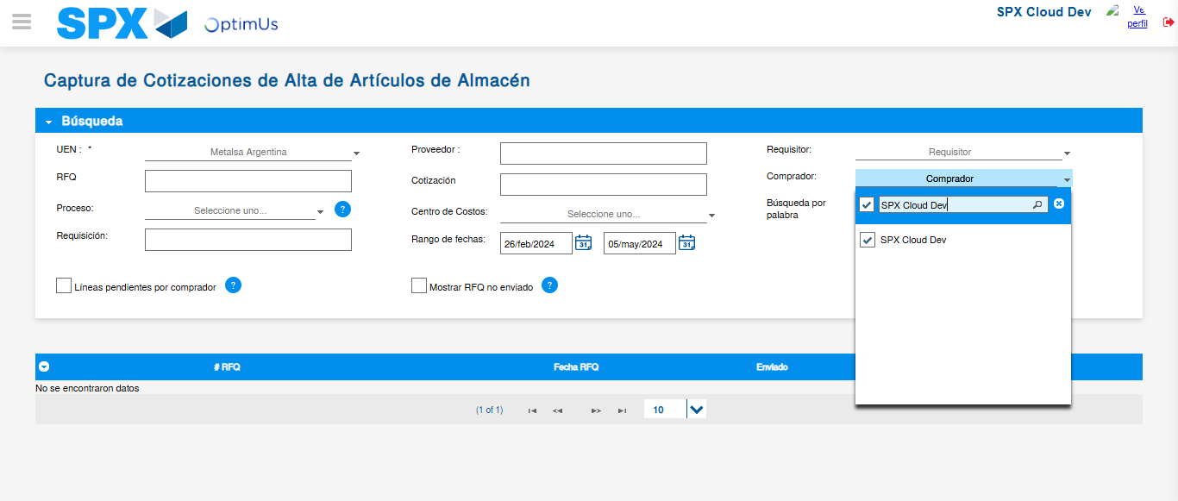Image file-name: QC_Testing-runTestMultipleTimes-dic. 04 2025, 04 08 10 p. m.

Image file-name: QC_Testing-runTestMultipleTimes-dic. 04 2025, 04 08 36 p. m.

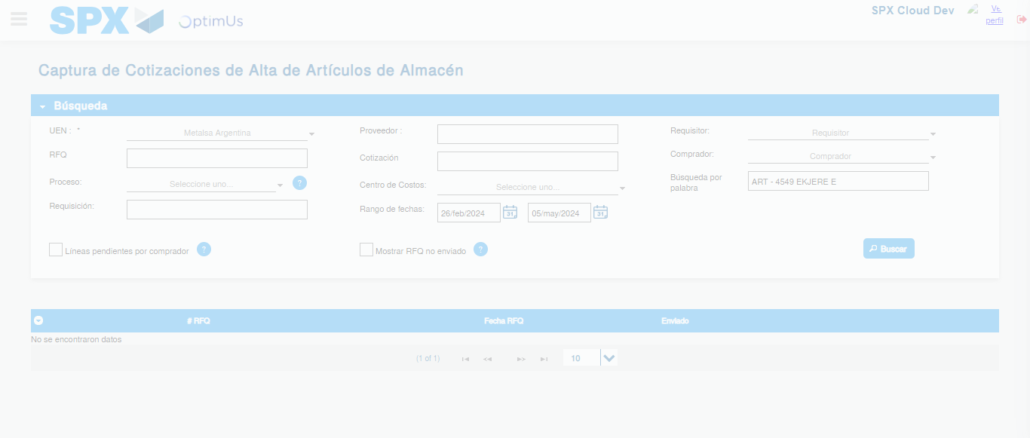Image file-name: QC_Testing-runTestMultipleTimes-dic. 04 2025, 04 08 40 p. m.

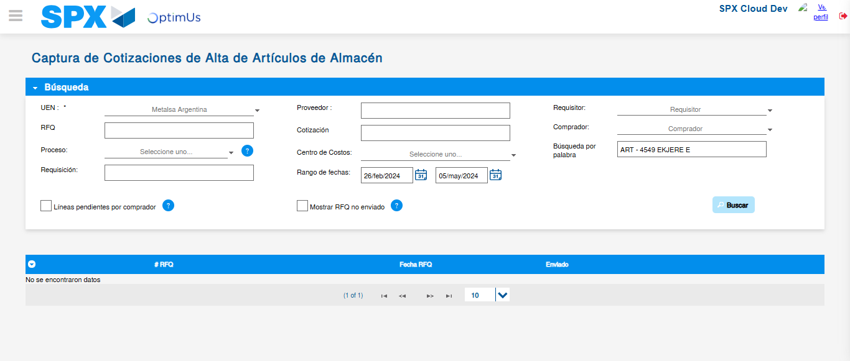Image file-name: QC_Testing-runTestMultipleTimes-dic. 04 2025, 04 08 43 p. m.

